SQL

🌟 Definition
# Source: AI Source: Provided by: [Data Path: Persons Table -> ID Column: 1, Name_En Column: Motasem Essam] -> From: [ChatGPT] on [6/11/2026]
SQL (Structured Query Language) is the standard language used to communicate with relational databases.
It allows you to:
- Create databases and tables
- Store data
- Retrieve data
- Update data
- Delete data
- Manage database security
- Control database transactions
SQL is the primary language used with databases such as:
- MySQL
- PostgreSQL
- Microsoft SQL Server
- Oracle Database
- SQLite

🔍 What is a Query Language?
# Source: AI Source: Provided by: [Data Path: Persons Table -> ID Column: 1, Name_En Column: Motasem Essam] -> From: [ChatGPT] on [6/11/2026]
A Query Language is a language used to request, retrieve, manipulate, or manage data from a data source such as a database, search engine, or API.

A Query Language allows you to:
- Retrieve data
- Insert data
- Update data
- Delete data
- Filter data
- Sort data
- Aggregate data

🌍 What is ANSI/ISO standard and relation to SQL

What is ANSI/ISO Standard?
# Source: AI Source: Provided by: [Data Path: Persons Table -> ID Column: 1, Name_En Column: Motasem Essam] -> From: [ChatGPT] on [6/11/2026]
An ANSI/ISO Standard is an officially agreed set of rules and specifications created by standards organizations to ensure that technologies work consistently across different vendors and systems.
ANSI
ANSI = American National Standards Institute
An organization that coordinates standards in the United States.
ISO
ISO = International Organization for Standardization
An international organization that develops global standards used worldwide.

Why Standards Exist
# Source: AI Source: Provided by: [Data Path: Persons Table -> ID Column: 1, Name_En Column: Motasem Essam] -> From: [ChatGPT] on [6/11/2026]
Without standards:
Company A SQL ≠ Company B SQL
Every database would use completely different commands.
Developers would have to learn a new language for each database.

With standards:
# Source: AI Source: Provided by: [Data Path: Persons Table -> ID Column: 1, Name_En Column: Motasem Essam] -> From: [ChatGPT] on [6/11/2026]
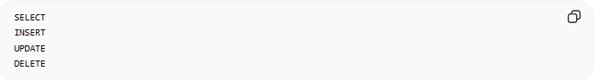
SELECT
INSERT
UPDATE
DELETE
work similarly across most database systems.

Relationship Between SQL and ANSI/ISO
# Source: AI Source: Provided by: [Data Path: Persons Table -> ID Column: 1, Name_En Column: Motasem Essam] -> From: [ChatGPT] on [6/11/2026]
SQL is an ANSI/ISO standardized language.
This means ANSI and ISO define the official SQL specification.
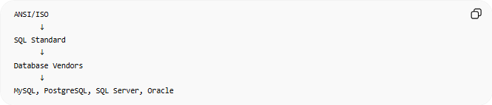
ANSI/ISO
↓
SQL Standard
↓
Database Vendors
↓
MySQL, PostgreSQL, SQL Server, Oracle
Database vendors try to follow the SQL standard.

Example
# Source: AI Source: Provided by: [Data Path: Persons Table -> ID Column: 1, Name_En Column: Motasem Essam] -> From: [ChatGPT] on [6/11/2026]
The SQL standard defines:
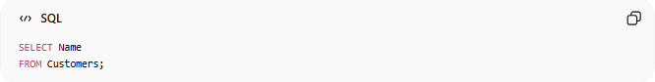
SELECT Name
FROM Customers;
Because this is standard SQL:
- MySQL understands it
- PostgreSQL understands it
- SQL Server understands it
- Oracle understands it
with little or no modification.

History of SQL Standards
# Source: AI Source: Provided by: [Data Path: Persons Table -> ID Column: 1, Name_En Column: Motasem Essam] -> From: [ChatGPT] on [6/11/2026]
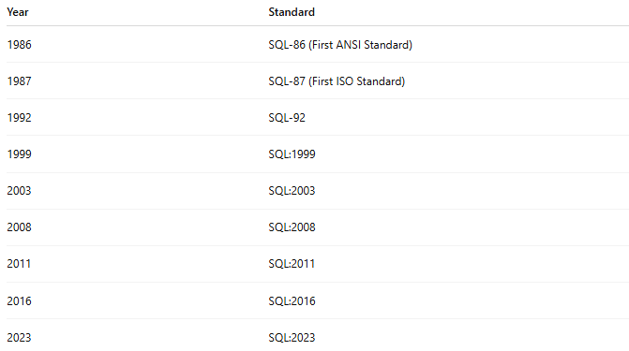
Year | Standard
1986 | SQL-86 (First ANSI Standard)
1987 | SQL-87 (First ISO Standard)
1992 | SQL-92
1999 | SQL:1999
2003 | SQL:2003
2008 | SQL:2008
2011 | SQL:2011
2016 | SQL:2016
2023 | SQL:2023
Each version added new features and improvements.

What ANSI/ISO Standardizes
# Source: AI Source: Provided by: [Data Path: Persons Table -> ID Column: 1, Name_En Column: Motasem Essam] -> From: [ChatGPT] on [6/11/2026]
1. SQL Syntax
Example:
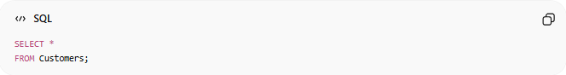
SELECT *
FROM Customers;

2. Data Types
Examples:
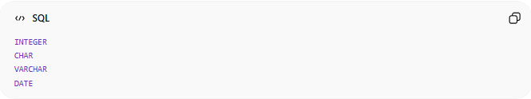
INTEGER
CHAR
VARCHAR
DATE

3. Constraints
Examples:
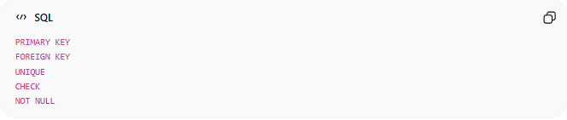
PRIMARY KEY
FOREIGN KEY
UNIQUE
CHECK
NOT NULL

4. Transactions
Examples:
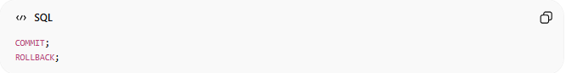
COMMIT;
ROLLBACK;

5. Joins
Examples:
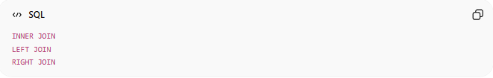
INNER JOIN
LEFT JOIN
RIGHT JOIN

Why SQL Databases Are Not 100% Identical
# Source: AI Source: Provided by: [Data Path: Persons Table -> ID Column: 1, Name_En Column: Motasem Essam] -> From: [ChatGPT] on [6/11/2026]
Although SQL is standardized:
Every vendor adds extra features.

Standard SQL
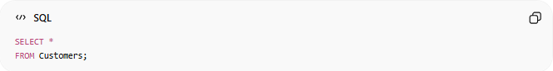
SELECT *
FROM Customers;
Works almost everywhere.

MySQL-Specific
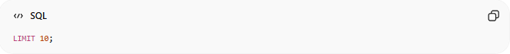
LIMIT 10;

SQL Server-Specific
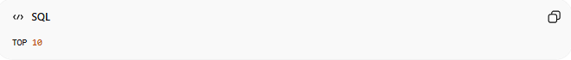
TOP 10

Both mean:
Return only 10 rows.
But the syntax differs.

Standard SQL vs Vendor Extensions
# Source: AI Source: Provided by: [Data Path: Persons Table -> ID Column: 1, Name_En Column: Motasem Essam] -> From: [ChatGPT] on [6/11/2026]
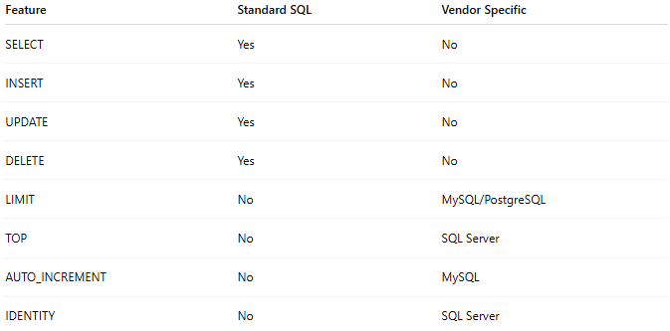
Feature | Standard SQL | Vendor Specific
SELECT | Yes | No
INSERT | Yes | No
UPDATE | Yes | No
DELETE | Yes | No
LIMIT | No | MySQL/PostgreSQL
TOP | No | SQL Server
AUTO_INCREMENT | No | MySQL
IDENTITY | No | SQL Server

🌍 Real Example
# Source: AI Source: Provided by: [Data Path: Persons Table -> ID Column: 1, Name_En Column: Motasem Essam] -> From: [ChatGPT] on [6/11/2026]
Suppose you write:
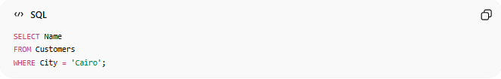
SELECT Name
FROM Customers
WHERE City = 'Cairo';
This query follows the ANSI/ISO SQL standard.
Therefore it will work in:
- MySQL
- PostgreSQL
- Microsoft SQL Server
- Oracle Database
- SQLite

🏗️ Why Developers Prefer Standard SQL
# Source: AI Source: Provided by: [Data Path: Persons Table -> ID Column: 1, Name_En Column: Motasem Essam] -> From: [ChatGPT] on [6/11/2026]
Benefits:
- Easier to learn
- More portable
- Works across multiple databases
- Reduces vendor lock-in
- Easier migration between systems

🧠 Simple Analogy
# Source: AI Source: Provided by: [Data Path: Persons Table -> ID Column: 1, Name_En Column: Motasem Essam] -> From: [ChatGPT] on [6/11/2026]
Think of traffic rules.
The standard says:
Red Light = Stop
Green Light = Go
All car manufacturers must follow these rules.
Similarly:
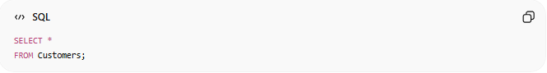
SELECT *
FROM Customers;
is a standard SQL rule that database vendors follow.
They may add extra features, but they still follow the common standard.

🧭 Summary
# Source: AI Source: Provided by: [Data Path: Persons Table -> ID Column: 1, Name_En Column: Motasem Essam] -> From: [ChatGPT] on [6/11/2026]
ANSI (American National Standards Institute) and ISO (International Organization for Standardization) define the official SQL standard. This standard specifies how SQL should work, including syntax, data types, constraints, joins, and transactions. Database systems such as MySQL, PostgreSQL, SQL Server, Oracle, and SQLite implement these standards, while also adding their own vendor-specific extensions. This standardization is what makes SQL largely portable across different database platforms.

🎯 Why SQL is Important
# Source: AI Source: Provided by: [Data Path: Persons Table -> ID Column: 1, Name_En Column: Motasem Essam] -> From: [ChatGPT] on [6/11/2026]
SQL helps applications work with data.
Examples:
- E-commerce websites store products and orders.
- Banks store customer accounts and transactions.
- Schools store students and courses.
- Social media platforms store users and posts.
Without SQL, managing large amounts of data would be difficult.

🧠 What SQL Can Do
# Source: AI Source: Provided by: [Data Path: Persons Table -> ID Column: 1, Name_En Column: Motasem Essam] -> From: [ChatGPT] on [6/11/2026]
1. Create Tables
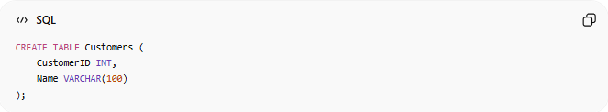
CREATE TABLE Customers (
CustomerID INT,
Name VARCHAR(100)
);
Creates a table named Customers.

2. Insert Data
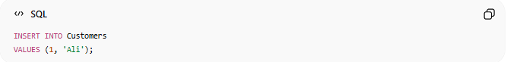
INSERT INTO Customers
VALUES (1, 'Ali');
Adds a new record.

3. Retrieve Data
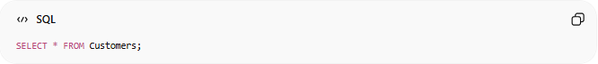
SELECT * FROM Customers;
Displays all records.

4. Update Data
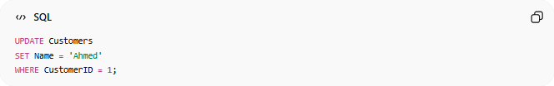
UPDATE Customers
SET Name = 'Ahmed'
WHERE CustomerID = 1;
Modifies existing data.

5. Delete Data
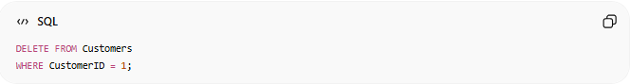
DELETE FROM Customers
WHERE CustomerID = 1;
Removes a record.

📚 Real-World Example
# Source: AI Source: Provided by: [Data Path: Persons Table -> ID Column: 1, Name_En Column: Motasem Essam] -> From: [ChatGPT] on [6/11/2026]
Customers Table
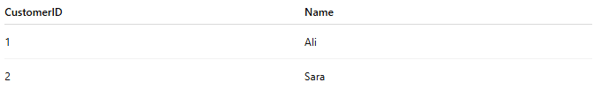
CustomerID | Name
1 | Ali
2 | Sara

Query
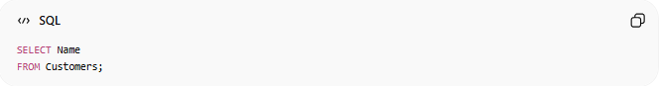
SELECT Name
FROM Customers;
Result
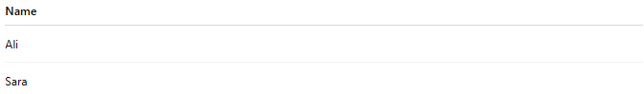
Name
Ali
Sara

🧩 Main SQL Categories

1. DDL (Data Definition Language)
# Source: AI Source: Provided by: [Data Path: Persons Table -> ID Column: 1, Name_En Column: Motasem Essam] -> From: [ChatGPT] on [6/11/2026]
Used to define database structures.
Commands:
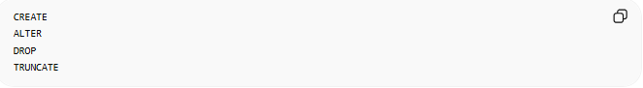
CREATE
ALTER
DROP
TRUNCATE
Example:
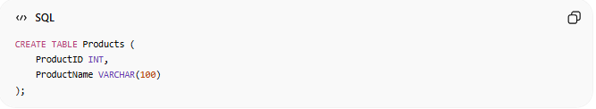
CREATE TABLE Products (
ProductID INT,
ProductName VARCHAR(100)
);

2. DML (Data Manipulation Language)
# Source: AI Source: Provided by: [Data Path: Persons Table -> ID Column: 1, Name_En Column: Motasem Essam] -> From: [ChatGPT] on [6/11/2026]
Used to modify data.
Commands:
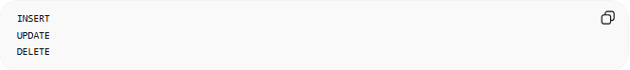
INSERT
UPDATE
DELETE
Example:
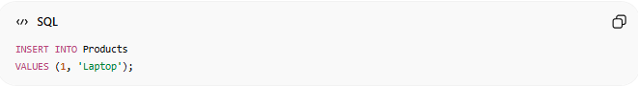
INSERT INTO Products
VALUES (1, 'Laptop');

3. DQL (Data Query Language)
# Source: AI Source: Provided by: [Data Path: Persons Table -> ID Column: 1, Name_En Column: Motasem Essam] -> From: [ChatGPT] on [6/11/2026]
Used to retrieve data.
Command:
SELECT
Example:
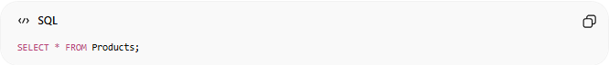
SELECT * FROM Products;

4. DCL (Data Control Language)
# Source: AI Source: Provided by: [Data Path: Persons Table -> ID Column: 1, Name_En Column: Motasem Essam] -> From: [ChatGPT] on [6/11/2026]
Used for permissions and security.
Commands:
GRANT
REVOKE
Example:
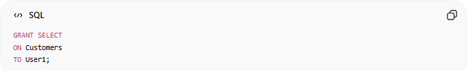
GRANT SELECT
ON Customers
TO User1;

5. TCL (Transaction Control Language)
# Source: AI Source: Provided by: [Data Path: Persons Table -> ID Column: 1, Name_En Column: Motasem Essam] -> From: [ChatGPT] on [6/11/2026]
Used to manage transactions.
Commands:
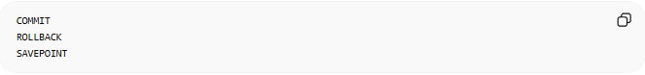
COMMIT
ROLLBACK
SAVEPOINT
Example:
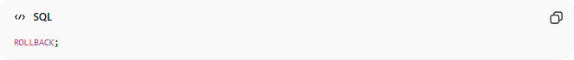
ROLLBACK;

🔢 SQL Keywords
# Source: AI Source: Provided by: [Data Path: Persons Table -> ID Column: 1, Name_En Column: Motasem Essam] -> From: [ChatGPT] on [6/11/2026]
Common SQL keywords:
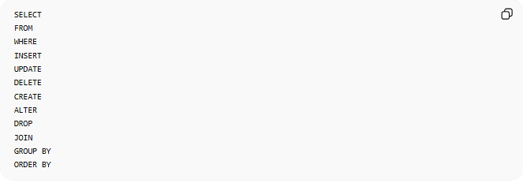
SELECT
FROM
WHERE
INSERT
UPDATE
DELETE
CREATE
ALTER
DROP
JOIN
GROUP BY
ORDER BY

🔍 Example Query
# Source: AI Source: Provided by: [Data Path: Persons Table -> ID Column: 1, Name_En Column: Motasem Essam] -> From: [ChatGPT] on [6/11/2026]
Products Table
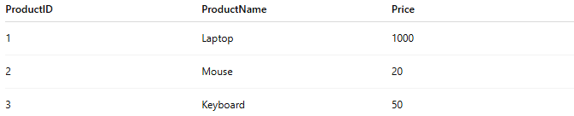
ProductID | ProductName | Price
1 | Laptop | 1000
2 | Mouse | 20
3 | Keyboard | 50

Query
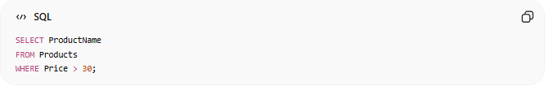
SELECT ProductName
FROM Products
WHERE Price > 30;
Result
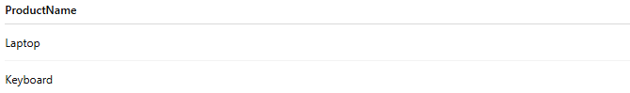
ProductName
Laptop
Keyboard

🔗 SQL and Databases
# Source: AI Source: Provided by: [Data Path: Persons Table -> ID Column: 1, Name_En Column: Motasem Essam] -> From: [ChatGPT] on [6/11/2026]
Relationship:
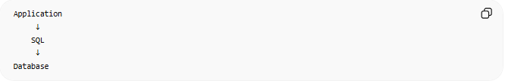
Application
↓
SQL
↓
Database
Example:
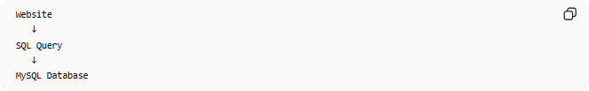
Website
↓
SQL Query
↓
MySQL Database

🌍 SQL in Everyday Applications
# Source: AI Source: Provided by: [Data Path: Persons Table -> ID Column: 1, Name_En Column: Motasem Essam] -> From: [ChatGPT] on [6/11/2026]
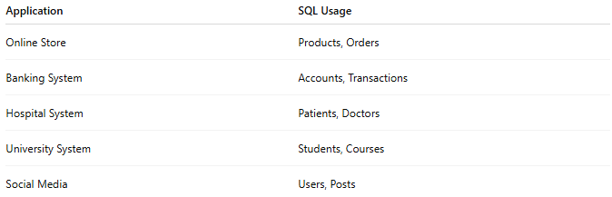
Application | SQL Usage
Online Store | Products, Orders
Banking System | Accounts, Transactions
Hospital System | Patients, Doctors
University System | Students, Courses
Social Media | Users, Posts

⚠️ SQL vs Database
# Source: AI Source: Provided by: [Data Path: Persons Table -> ID Column: 1, Name_En Column: Motasem Essam] -> From: [ChatGPT] on [6/11/2026]
SQL
Language
Used to communicate with databases.
Example:
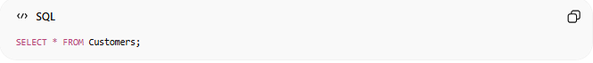
SELECT * FROM Customers;

Database
Storage System
Stores the actual data.
Example:
MySQL Database
PostgreSQL Database

🔸 Differences Across Popular Databases
# Source: AI Source: Provided by: [Data Path: Persons Table -> ID Column: 1, Name_En Column: Motasem Essam] -> From: [ChatGPT] on [6/11/2026]
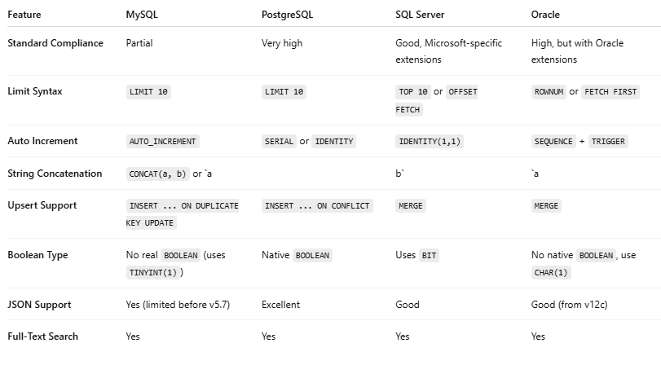
Feature | MySQL | PostgreSQL | SQL Server | Oracle
Standard Compliance | Partial | Very high | Good, Microsoft-specific extensions | High, but with Oracle extensions
Limit Syntax | LIMIT 10 | LIMIT 10 | TOP 10 or OFFSET FETCH | ROWNUM or FETCH FIRST
Auto Increment | AUTO_INCREMENT | SERIAL or IDENTITY | IDENTITY(1,1) | SEQUENCE + TRIGGER
String Concatenation | CONCAT(a, b) or `a |  | b` | `a
Upsert Support | INSERT ... ON DUPLICATE KEY UPDATE | INSERT ... ON CONFLICT | MERGE | MERGE
Boolean Type | No real BOOLEAN (uses TINYINT(1)) | Native BOOLEAN | Uses BIT | No native BOOLEAN, use CHAR(1)
JSON Support | Yes (limited before v5.7) | Excellent | Good | Good (from v12c)
Full-Text Search | Yes | Yes | Yes | Yes

⚖️ side-by-side comparison
# Source: AI Source: Provided by: [Data Path: Persons Table -> ID Column: 1, Name_En Column: Motasem Essam] -> From: [ChatGPT] on [6/11/2026]
Here's a side-by-side comparison of how a simple UPSERT (insert or update) operation would be written in different SQL dialects. This is a good example because UPSERT is handled differently across database systems, even though the intent is the same.

🔍 Goal
# Source: Chatgpt (GPT-4-turbo) at [6/5/2025]
Insert a user into the users table. If a user with the same id already exists, update their email.

🟢 PostgreSQL (standards-compliant + powerful)
# Source: Chatgpt (GPT-4-turbo) at [6/5/2025]
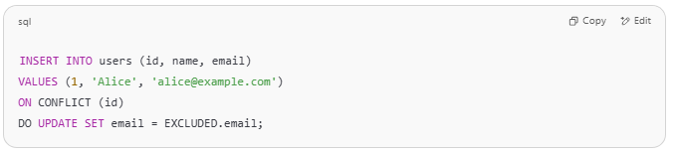
INSERT INTO users (id, name, email)
VALUES (1, 'Alice', 'alice@example.com')
ON CONFLICT (id)
DO UPDATE SET email = EXCLUDED.email;

- ON CONFLICT handles primary key or unique constraint violations.
- EXCLUDED is a special alias for the row that was rejected.

🔵 MySQL
# Source: Chatgpt (GPT-4-turbo) at [6/5/2025]
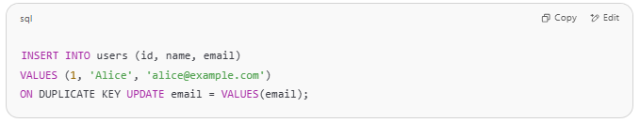
INSERT INTO users (id, name, email)
VALUES (1, 'Alice', 'alice@example.com')
ON DUPLICATE KEY UPDATE email = VALUES(email);

- Triggers on duplicate primary or unique keys.
- VALUES(email) refers to the input value.

🟡 SQL Server (Microsoft T-SQL)
# Source: Chatgpt (GPT-4-turbo) at [6/5/2025]
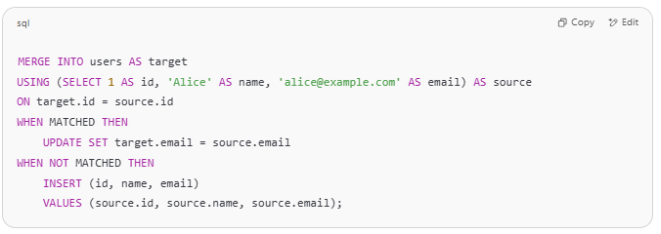
MERGE INTO users AS target
USING (SELECT 1 AS id, 'Alice' AS name, 'alice@example.com' AS email) AS source
ON target.id = source.id
WHEN MATCHED THEN
UPDATE SET target.email = source.email
WHEN NOT MATCHED THEN
INSERT (id, name, email)
VALUES (source.id, source.name, source.email);

- Uses MERGE for complex upsert logic.
- Verbose but flexible.

🔴 Oracle
# Source: Chatgpt (GPT-4-turbo) at [6/5/2025]
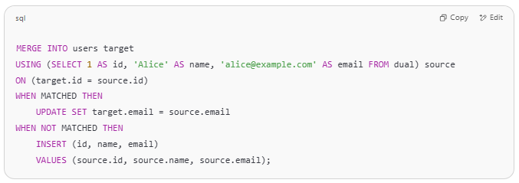
MERGE INTO users target
USING (SELECT 1 AS id, 'Alice' AS name, 'alice@example.com' AS email FROM dual) source
ON (target.id = source.id)
WHEN MATCHED THEN
UPDATE SET target.email = source.email
WHEN NOT MATCHED THEN
INSERT (id, name, email)
VALUES (source.id, source.name, source.email);

- Similar to SQL Server, uses MERGE.
- DUAL is a dummy table used in Oracle for SELECT statements without a table.

✅ Summary Table
# Source: Chatgpt (GPT-4-turbo) at [6/5/2025]
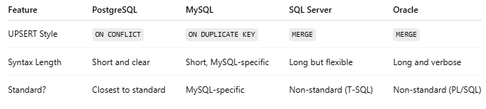
Feature | PostgreSQL | MySQL | SQL Server | Oracle
UPSERT Style | ON CONFLICT | ON DUPLICATE KEY | MERGE | MERGE
Syntax Length | Short and clear | Short, MySQL-specific | Long but flexible | Long and verbose
Standard? | Closest to standard | MySQL-specific | Non-standard (T-SQL) | Non-standard (PL/SQL)

🧠 Simple Analogy
# Source: AI Source: Provided by: [Data Path: Persons Table -> ID Column: 1, Name_En Column: Motasem Essam] -> From: [ChatGPT] on [6/11/2026]
Think of a restaurant:
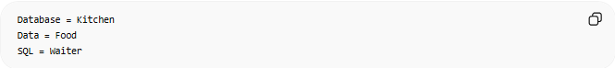
Database = Kitchen
Data = Food
SQL = Waiter
You tell the waiter what you want:
Bring me a pizza.
The waiter communicates with the kitchen and returns the result.
Similarly:
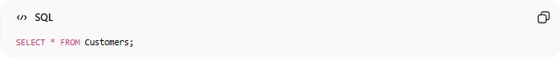
SELECT * FROM Customers;
SQL communicates with the database and returns the requested data.

🧭 Summary
# Source: AI Source: Provided by: [Data Path: Persons Table -> ID Column: 1, Name_En Column: Motasem Essam] -> From: [ChatGPT] on [6/11/2026]
SQL (Structured Query Language) is the standard language used to work with relational databases. It allows users to create, read, update, and delete data, as well as manage database structures, permissions, and transactions. SQL is used with database systems such as MySQL, PostgreSQL, SQL Server, Oracle, and SQLite, making it one of the most important technologies in database development.

